1

Code:

libname college 'C:\Users\Samil\Desktop\Sem 1\Stats for programming\SAS 9.4';

options linesize=**64** pagesize=**24**;

title "Weeks";

pattern value=empty;

**proc** **gchart** data=college.cat2;

vbar week_0 week_1 week_2;

**run**;

title;

Log:

19 options linesize=64 pagesize=24;

20 title "Weeks";

21 pattern value=empty;

NOTE: There were 8 observations read from the data set

COLLEGE.CAT2.

NOTE: PROCEDURE GCHART used (Total process time):

real time 43.92 seconds

cpu time 6.48 seconds

22 proc gchart data=college.cat2;

23 vbar week_0 week_1 week_2;

24 run;

NOTE: 10155 bytes written to

C:\Users\Samil\AppData\Local\Temp\SAS Temporary

Files\_TD10236_DESKTOP-H3OLVE7_\gchart6.png.

NOTE: 9938 bytes written to

C:\Users\Samil\AppData\Local\Temp\SAS Temporary

Files\_TD10236_DESKTOP-H3OLVE7_\gchart7.png.

NOTE: 10371 bytes written to

C:\Users\Samil\AppData\Local\Temp\SAS Temporary

Files\_TD10236_DESKTOP-H3OLVE7_\gchart8.png.

25 title;

Output:

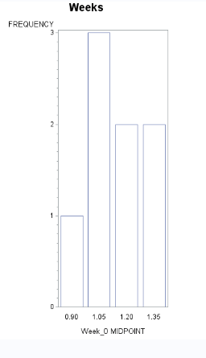

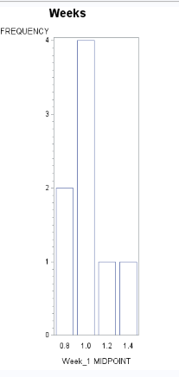

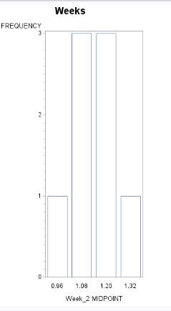

2

Code:

**data** prob2;

length group $ **1**;

input X Y Z Group $;

datalines;

2 4 6 A

3 3 3 B

1 3 7 A

7 5 3 B

1 1 5 B

2 2 4 A

5 5 6 A

;

**run**;

options linesize=**70** pagesize=**35**;

(a)

**proc** **chart** data=prob2;

Title 'Chart of Prob2';

vbar group/type=freq;

**quit**;

Title;

(b)

**proc** **sort** data=prob2

out=prob2_sort;

by group;

**run**;

**proc** **plot** data=prob2_sort ;

Title 'Plot of Y on vertical and X on horizontal axis';

plot y*x='*';

**quit**;

**run**;

Title;

(c)

**proc** **plot** data=prob2_sort ;

Title 'Plot of Y on vertical and X on horizontal axis By group';

plot y*x='*';

by group;

**quit**;

**run**;

Title;

Log:

264 data prob2;

265 length group $ 1;

266 input X Y Z Group $;

267 datalines;

NOTE: The data set WORK.PROB2 has 7 observations and 4 variables.

NOTE: DATA statement used (Total process time):

real time 0.06 seconds

cpu time 0.04 seconds

275 ;

276 run;

277

278 options linesize=70 pagesize=35;

279

280 proc chart data=prob2;

281 Title 'Chart of Prob2';

282 vbar group/type=freq;

283 quit;

NOTE: PROCEDURE CHART used (Total process time):

real time 0.12 seconds

cpu time 0.01 seconds

284 Title;

285

286 proc sort data=prob2

287 out=prob2_sort;

288 by group;

289 run;

NOTE: There were 7 observations read from the data set WORK.PROB2.

NOTE: The data set WORK.PROB2_SORT has 7 observations and 4 variables.

NOTE: PROCEDURE SORT used (Total process time):

real time 0.06 seconds

cpu time 0.06 seconds

290

291 proc plot data=prob2_sort ;

292 Title 'Plot of Y on vertical and X on horizontal axis';

293 plot y*x='*';

294 quit;

NOTE: There were 7 observations read from the data set

WORK.PROB2_SORT.

NOTE: PROCEDURE PLOT used (Total process time):

real time 0.10 seconds

cpu time 0.04 seconds

295 run;

296 Title;

297

298 proc plot data=prob2_sort ;

299 Title 'Plot of Y on vertical and X on horizontal axis By group';

300 plot y*x='*';

301 by group;

302 quit;

NOTE: There were 7 observations read from the data set

WORK.PROB2_SORT.

NOTE: PROCEDURE PLOT used (Total process time):

real time 0.35 seconds

cpu time 0.01 seconds

303 run;

304 Title;

Output:

a

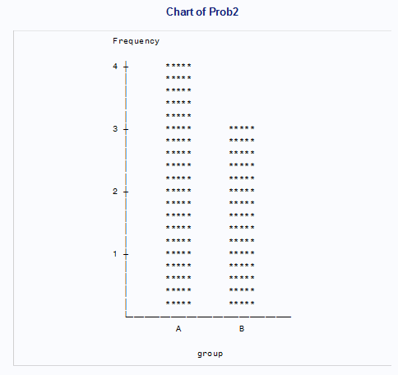

b

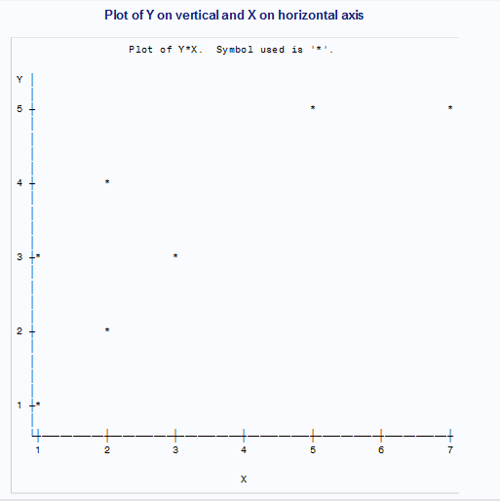

c

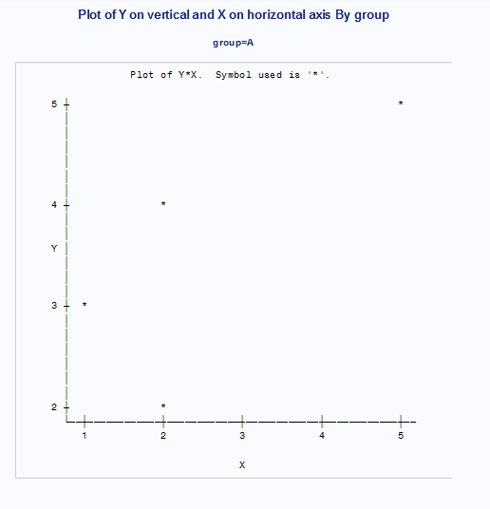

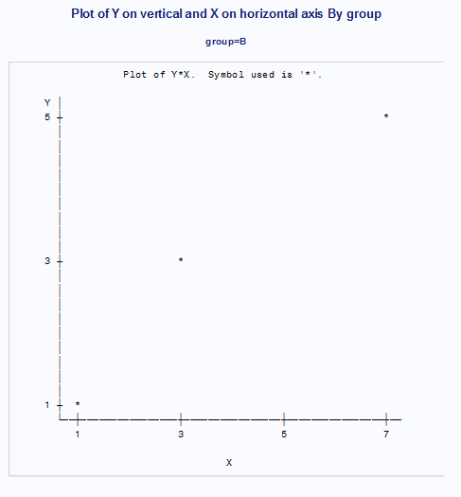

3

Code:

title "Vertical Charts";

pattern value=empty;

options linesize=**65** pagesize=**24**;

**proc** **gchart** data=college.Bicycles;

vbar Country Model/type=freq;

**run**;

**quit**;

title;

Log:

45 options linesize=65 pagesize=24;

46 title "Vertical Charts";

47 pattern value=empty;

48

49 options linesize=65 pagesize=24;

50 proc gchart data=college.Bicycles;

51 vbar Country Model/type=freq;

52 run;

NOTE: 11485 bytes written to

C:\Users\Samil\AppData\Local\Temp\SAS Temporary

Files\_TD10236_DESKTOP-H3OLVE7_\gchart11.png.

NOTE: 11605 bytes written to

C:\Users\Samil\AppData\Local\Temp\SAS Temporary

Files\_TD10236_DESKTOP-H3OLVE7_\gchart12.png.

53 quit;

NOTE: There were 18 observations read from the data set

COLLEGE.BICYCLES.

NOTE: PROCEDURE GCHART used (Total process time):

real time 0.62 seconds

cpu time 0.39 seconds

54 title;

Output:

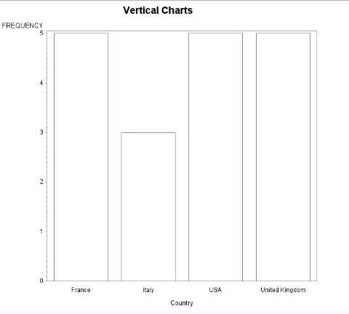

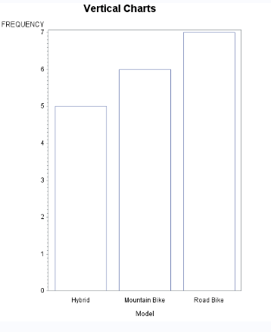

4

Code:

title "Price Versus Date";

symbol value=dot interpol=sms line=**1** width=**2**;

**proc** **gplot** data=college.Stocks1;

plot Price*Date;

**run**;

Title;

Log:

55 title "Price Versus Date";

56 symbol value=dot interpol=sms line=1 width=2;

57 proc gplot data=college.Stocks1;

58 plot Price*Date;

59 run;

NOTE: 26626 bytes written to

C:\Users\Samil\AppData\Local\Temp\SAS Temporary

Files\_TD10236_DESKTOP-H3OLVE7_\gplot.png.

60 Title;

Output:

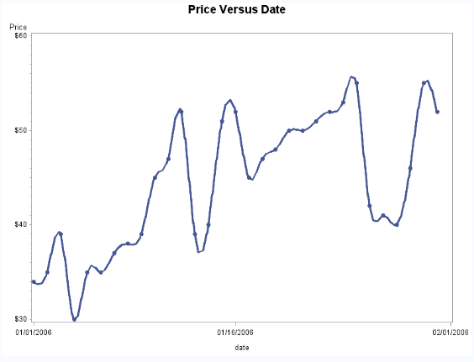

5

Code:

**data** Sat;

input Year Lower Upper;

datalines;

2015 1200 1360

2014 1170 1330

2013 1170 1330

2012 1140 1330

2011 1130 1320

2010 1110 1310

2009 1140 1310

2008 1120 1290

2007 1130 1300

2006 1150 1310

;

**run**;

Title 'Plot for Sat Scores';

symbol value=dot line=**1** width=**2**;

options linesize=**80** pagesize=**35**;

**proc** **plot** data=Sat;

plot Lower * Year='v' Upper*Year='^'/overlay Vaxis=**1000** to **1400** by **100**;

**run**;

**quit**;

title;

Log:

81 Title 'Plot for Sat Scores';

82 symbol value=dot line=1 width=2;

83 options linesize=80 pagesize=35;

84 proc plot data=Sat;

85 plot Lower * Year='v' Upper*Year='^'/overlay Vaxis=1000 to 1400 by 100;

86 run;

87 quit;

NOTE: There were 10 observations read from the data set WORK.SAT.

NOTE: PROCEDURE PLOT used (Total process time):

real time 0.10 seconds

cpu time 0.03 seconds

88 title;

Output:

